Packet Tracer – Explore the Smart Home

Topology

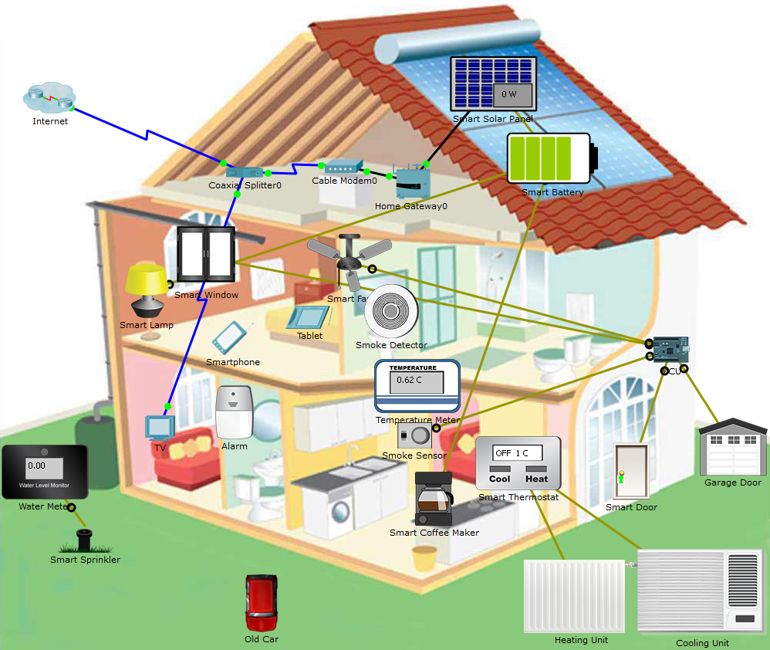

1. Objectives

* **Explore the Smart Home**
* **Analyze the Usage of Fog Computing in the Smart Home**

1. Background / Scenario

In this activity, you will explore the smart home example. Depending on the application, some data is best processed close to the source. The smart home example takes advantage of fog computing to monitor and act upon the levels of smoke detected in the home.

1. Explore the Smart Home
   * 1. Understanding the devices that comprise the smart home

Commonly ISPs deliver data and video over a single coaxial cable. Starting from the attic, a coaxial splitter is used to separate the video signal from the data signal.

* + - 1. Two coaxial cables leave the coaxial splitter in the topology shown. Which devices does the coaxial cable connect to?

____________________________________________________________________________________

* + - 1. The cable modem is the interface between the ISP’s network and the home’s network. To which devices does the cable modem connect to?

____________________________________________________________________________________

The Home Gateway acts a concentrator and router to all internal home devices. It also provides a web-based interface that allows users to monitor and control various smart home devices. Notice that the home devices can connect to the Home Gateway through either a wireless and/or wired connection.

Note: Packet Tracer uses dashed beams to represent wireless connections but it can make it hard to read when too many devices are present. To turn it on, go to **Options** > **Preferences** > **Hide** Tab > uncheck **Hide Wireless/Cellular Connection.**

* + - 1. List all home devices connected to the Home Gateway

____________________________________________________________________________________

____________________________________________________________________________________

____________________________________________________________________________________

____________________________________________________________________________________

____________________________________________________________________________________

* + 1. Interacting With the Smart Home

The devices in the smart home can be monitored and controlled remotely through any computer in the home. Because all smart devices connect to the Home Gateway which hosts a web-based interface, tablets, smartphones, laptops or desktop computers can be used to interact with the smart devices.

* + - 1. Click the **Tablet**. (The tablet is located on the bed in the master bedroom).
      2. Navigate to **Desktop** > **Web Browser**.
      3. In the address bar, type in **192.168.25.1** and press Enter. This is the IP address of the Home Gateway.
      4. Use **admin**/**admin** as username and password to log into the Home Gateway.
      5. What is displayed?

____________________________________________________________________________________

* + - 1. The smart door is currently unlocked (represented by a green light on its door knob) but it can be locked remotely. Click the smart door in the browser to expand the option.
      2. Click **Lock** to lock the door.
      3. Was the door locked? How do you know?

____________________________________________________________________________________

* + - 1. Click **Unlock** to unlock the door.
      2. Click the smoke detector in the browser to expand the section. What is the smoke level reading provided by the smoke detector?

____________________________________________________________________________________

* + - 1. Can the smoke detector be controlled?

____________________________________________________________________________________

Smart devices can also be controlled directly, representing physical interaction.

* + - 1. Within the Logical work area of Packet Tracer, hold down the ALT key and click the **Smart Coffee Maker** to turn it on or off.

1. Fog Computing in the Smart Home

The MCU added to the smart home is used to monitor the smoke levels read by the smoke sensor and decide if the house should be ventilated. If the carbon monoxide levels raises above 10.3 units, the MCU is programmed to automatically open the window, front door, garage door and start the fan in high speed. This action is only reverted (close doors and windows and stop the fan) when the carbon monoxide levels drop below 1 unit.

* + 1. Run the Classic Car

The owner keeps a classic car in the garage and needs to be run occasionally. The classic car generates carbon monoxide which raises the levels within the premises.

* + - 1. Click the **Tablet** located on the bed in the master bedroom.
      2. Navigate to **Desktop** > **Web Browser**.
      3. In the address bar, type in **192.168.25.1**. This is the IP address of the Home Gateway.
      4. Use **admin**/**admin** as username and password to log into the Home Gateway.
      5. Click on the Smoke Detector within the smart home; leave this window visible so you can monitor the smoke levels.
      6. Start the car engine by holding the Alt key and clicking the classic car.

What happens to the air inside the house with the car running inside the garage?

____________________________________________________________________________________

What happens to air inside the house after the MCU opens the doors and window, and start the fan?

____________________________________________________________________________________

Does the MCU close the doors and window, and stop the fan?

____________________________________________________________________________________

* + - 1. While still monitoring the levels, stop the classic car’s engine by holding the Alt key and clicking the classic car.

What happens to air quality inside the house after the engine is stopped?

____________________________________________________________________________________

What happens to the doors, window and fan?

____________________________________________________________________________________

1. Reflection

This example shows that the decision between cloud and fog processing depends on the application.

In the smart home example, fog computing was the best option. In the smart home example, the data generated by the smoke sensors were processed and used to make decisions regarding the house’s air quality. In this scenario, there was no need to need to send out sensor data to the cloud for processing. Cloud processing would slow down the response time, potentially putting lives in danger. Another possible problem relates to the Internet link; if the connection to the Internet was lost, the entire system would fail, putting lives at risk.